Assignment – 05
Q1. An assembly program to add two numbers and store the 8 bit sum in any general purpose register.
Ans: MVI A,20H;
MVI B,18H;
ADD B;
MOV C,A;
HLT;
Listing:
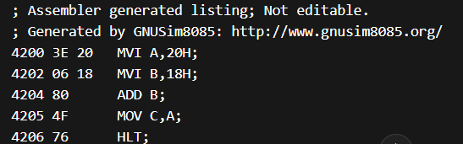
Q2. An assembly program to add two numbers and store the 8 bit sum in any Memory location.
Ans: MVI A,20H;
MVI B,18H;
ADD B;
STA 2020H;
HLT;
Listing:
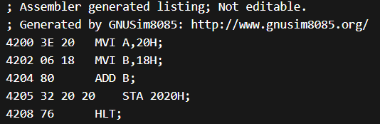
Q3. An assembly program to subtract two numbers and store the result in any general purpose resister.
Ans: MVI A,25H;
MVI B,15H;
SUB B;
MOV C,A;
HLT;
Listing:
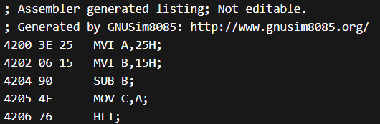
Q4. An assembly program to subtract two numbers and store the result in any Memory location . Ans:
MVI A,25H;
MVI B,15H;
SUB B;
STA 2000H;
HLT;
Listing:
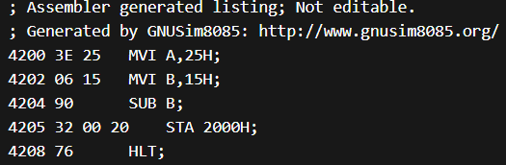
Q5. Writeaprogramin8085assemblylanguagetoperformthefollowing operations: a. Initialize Register B with some data in Hex form b. Initialize Register C with some data in Hex form c. Initialize Register D with some data in Hex form d. Add contents of register B and D e. If the sum is zero then: - increment the content of register C by 1 else – decrement the content of register C by1
Ans: MVI B,23H;
MVI C,01H;
MVI D,17H;
ADD B;
ADD D;
JZ ZERO;
DCR C;
JMP END;
ZERO: INR C;
END: HLT;
Listing:
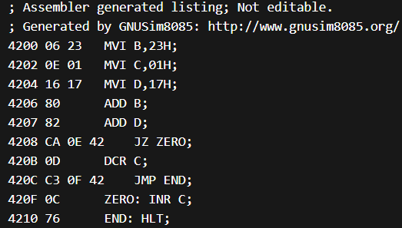
Q6. Write a program in 8085 assembly language to perform the following operations: f. Initialize Register B with 80H g. Initialize Register D with 84H h. Add contents of register B and D i. If the add operation generate an carry then: - Store the carry bit in memory location 2020 and 8-bit sum in 2021 memory location. else - Store only the 8-bit sum in 2021 memory location.
Ans: MVI B,80H;
MVI D,84H;
MOV A,B;
ADD D;
JNC NO_CARRY;
MVI A,01H;
STA 2020H;
MOV A,B;
ADD D;
STA 2021H;
JMP END;
NO_CARRY: STA 2021H;
END: HLT;
Listing:
